AGENTIC AI EMPLOYEE ONBOARDING SYSTEM
A LangGraph-Orchestrated Multi-Agent Platform for Resume Parsing, Onboarding, Scheduling, Leave Management and Policy Q&A
AD23731 Foundations of Agentic AI - Mini-Project
Submitted by
Ramprasath N 231501129
Thirumalai 231501174
Vijay M 231501182
Department of Artificial Intelligence and Machine Learning

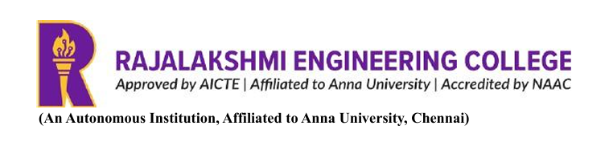
SEPTEMBER 2026

BONAFIDE CERTIFICATE

Certified that this mini-project report “AGENTIC AI EMPLOYEE ONBOARDING SYSTEM” is the bonafide work of “Vijay M (231501182), Ramprasath N(231501129), Thirumalai (231501174)” VII Semester, B.Tech. Artificial Intelligence and Machine Learning Department, in partial fulfilment of the requirements of the course AD23731 – Foundations of Agentic AI during the Academic Year 2026 – 2027.

Faculty in-charge

Submitted to mini-project viva voce examination held on: ………………………

INTERNAL EXAMINER EXTERNAL EXAMINER

AGENTIC AI EMPLOYEE ONBOARDING SYSTEM

1. INTRODUCTION

1.1 Background and Motivation
Employee onboarding is the process through which a newly hired person is integrated into an organisation. It involves collecting and verifying the candidate’s profile, creating an employee record, assigning orientation and compliance tasks, scheduling introductory meetings, explaining HR policies, and handling early requests such as leave. In most organisations these activities are spread across HR staff, managers, calendars, spreadsheets, e-mail threads and policy documents, which makes them slow, repetitive and prone to omission.
Traditional HR tools generally store records but do not actively carry out the multi-step work around them. A new joiner may miss a task, a manager may not know which meetings to schedule, and employees repeatedly ask HR the same policy questions. At the same time, simply placing a chatbot in front of HR data is not sufficient, because onboarding involves decisions that must be correct, auditable and access-controlled.
The Agentic AI Employee Onboarding System is a working prototype that addresses this problem. It uses LangGraph to orchestrate five specialised AI agents – Resume, Onboarding, Calendar, Leave and Policy (RAG) – under a Supervisor that routes each request. The system is built with Python 3.12, FastAPI, LangGraph, LangChain, Google Gemini (LLM and embeddings), FAISS, SQLAlchemy/SQLite and a React (Vite + Tailwind CSS) frontend.
The platform is designed not as a single conversational assistant but as an intelligent workflow system. It converts an uploaded resume into an employee record, generates a role-aware onboarding plan, schedules meetings, processes leave requests with human approval where required, and answers HR policy questions from retrieved policy documents. The project therefore addresses two interconnected challenges:
- How can the routine steps of onboarding (profile creation, task planning, scheduling, leave handling and policy answers) be automated reliably?
- How can this automation remain safe – with deterministic business logic, human approval for sensitive decisions, grounded answers and strict role-based access?
The combination of automation and control forms the central motivation behind the project.

1.2 Need for Intelligent and Agentic AI
Conventional HR software relies on forms, fixed workflows and manual follow-up. A single large language model, on the other hand, can answer questions but cannot reliably execute multi-step business processes or guarantee correct calculations. Onboarding is a multi-step decision problem rather than a single prediction task, and it benefits from separating responsibilities into specialised components.
In this system the tasks are divided as follows:
- A Supervisor component classifies the incoming request and routes it to the correct workflow.
- A Resume component converts an uploaded PDF resume into a structured employee profile.
- An Onboarding component generates a role- and department-aware task plan.
- A Calendar component schedules, reschedules and cancels meetings against realistic availability.
- A Leave component parses leave requests, applies balance and approval rules, and pauses for human approval when required.
- A Policy (RAG) component answers HR policy questions using retrieved policy documents only.
These agents do not behave as independent chatbots. They communicate only through a shared LangGraph state, and every important action is performed through tools and recorded in an activity log. This makes the behaviour of the system inspectable and repeatable. LangGraph’s interrupt mechanism additionally allows a workflow to stop at a human-approval step and resume later, which is not possible in a simple prompt-and-response design.

1.3 Project Objectives
The major objectives of the project are:
- To automate employee onboarding through a supervisor-routed, multi-agent LangGraph workflow.
- To extract a structured employee profile from an uploaded PDF resume.
- To generate a role- and department-aware onboarding task plan and store the tasks.
- To schedule, reschedule and cancel onboarding meetings against a calendar with work hours, lunch breaks and conflicts.
- To manage leave requests with deterministic balance and approval rules, including auto-approval, rejection and human-in-the-loop approval.
- To answer HR policy questions through Retrieval-Augmented Generation (RAG) grounded in policy documents, with source files listed.
- To enforce role-based access control (Employee, Manager, HR) on every request and every database query.
- To record every important agent action in an Agent Activity log for transparency.
- To keep the system functional even without an LLM key by providing deterministic fallbacks.
- To provide a containerised, extensible full-stack architecture that can later integrate real calendar providers and notification services.

2. PROBLEM STATEMENT AND BUSINESS CASE

2.1 Problem Definition
Organisations that hire regularly face difficulty in making onboarding consistent, timely and controlled. An effective onboarding process must simultaneously ensure:
- accurate capture of the new employee’s profile,
- a complete and role-appropriate task plan,
- correctly scheduled orientation and introductory meetings,
- policy-consistent leave decisions with correct balances,
- reliable answers to policy questions,
- confidentiality of data according to role, and
- an auditable record of what was done and by whom.
Existing approaches usually treat these as separate manual activities. Where AI is used, it is often a standalone chatbot that may hallucinate policy details, miscalculate leave balances or expose data to the wrong user. The problem addressed by this project can therefore be stated as:
Automate the end-to-end employee onboarding workflow using coordinated AI agents while keeping critical business logic deterministic, policy answers grounded in retrieved documents, sensitive decisions under human approval, and data access restricted by role.

2.2 Real-World Context
HR teams in growing organisations process resumes, create employee records, chase managers for orientation plans, book meetings and answer repeated questions on leave and policies. Managers must approve their team’s leave and track whether new joiners are completing their tasks, while employees want a single place to see their own tasks, meetings, leave balances and policy answers.
Different people need different views of the same system:
- An employee should see only their own tasks, meetings, leave and balances.
- A manager should additionally see their direct reports and approve or reject their leave.
- HR should have organisation-wide access, including resume upload and company-wide leave decisions.
Consequently, a single generic chatbot or a static workflow tool cannot satisfy every user. The system treats automation, correctness and access control as simultaneous requirements.

2.3 Business Case
The Agentic AI Employee Onboarding System can be considered an HR-automation platform with potential applications in:
- Corporate HR departments and onboarding teams
- Startups and growing companies without dedicated HR tooling
- IT services and consulting firms with frequent hiring
- Educational institutions onboarding faculty and staff
- HR-tech and HR-outsourcing providers
Potential future business models include:
- Software-as-a-Service subscription per organisation or per employee
- Integration with Google Calendar, Microsoft Graph and existing HRMS platforms
- Notification add-ons for e-mail and Slack approvals
- Premium analytics and onboarding-progress dashboards
- Managed deployment and customisation of company-specific policy knowledge bases
The current project focuses on developing and demonstrating the technical platform rather than implementing a commercial business model.

3. USER AND STAKEHOLDER ANALYSIS

3.1 Target Users
The system targets organisations that want to automate onboarding while keeping control over who can see and approve what. The seeded demo organisation contains seven employees arranged in a manager hierarchy, with one HR user, managers and employees.
Primary Users
HR Administrators. Upload resumes, create employees and logins, view the organisation-wide dashboard, and take leave decisions company-wide.
Managers. Track their direct reports’ onboarding progress and approve or reject their reports’ leave requests.
Employees and New Joiners. View and update their own tasks, attend meetings, request leave, check balances and ask policy questions.
Secondary Users
Organisation Leadership. Benefit from consistent onboarding and reduced HR workload.

3.2 Stakeholders
The major stakeholders include:
Stakeholder | Role
HR Team | Uploads resumes, creates employees, manages roles and takes company-wide leave decisions
Managers | Monitor direct reports and approve or reject their leave requests
Employees / New Joiners | Complete onboarding tasks, attend meetings, request leave and query policies
Project Team | Designs, develops and maintains the system
AI Service Provider (Google Gemini) | Provides LLM extraction, intent classification, answer generation and embeddings
Calendar Providers (future) | Google Calendar / Microsoft Graph can replace the mock calendar provider
IT / Security Administrators | Manage secrets, authentication and deployment
Organisation Management | Benefits from consistent and auditable onboarding

3.3 User Requirements
Functional Requirements
The system should allow users to:
- Sign in with e-mail and password and receive a role-specific interface.
- Upload a PDF resume (HR) and obtain a structured employee profile.
- Create employees and logins, with the access role derived from the e-mail prefix (HR).
- Change an existing user’s role (HR).
- View an auto-generated onboarding task plan and update own task status.
- View scheduled meetings and mark attendance; reschedule or cancel meetings (HR/Manager).
- Submit leave requests in natural language or through a form and view leave balances.
- Have leave requests auto-approved, rejected or routed for human approval according to policy.
- Approve or reject pending leave requests (Manager/HR).
- Ask HR policy questions and receive grounded answers with sources.
- View team members and their progress (Manager/HR).
- View organisation or team dashboards (HR/Manager).
- View the Agent Activity feed showing real agent actions.
- Check LLM and RAG health status.
Non-Functional Requirements
The system should provide:
- Security – hashed passwords (PBKDF2-SHA256), signed JWT tokens and server-side authorisation on every request
- Reliability – graceful degradation when the LLM or checkpoint is unavailable
- Usability – role-aware navigation and a clean dashboard-style interface
- Auditability – logs for every important agent action
- Maintainability – small, specialised agents and clearly separated modules
- Scalability – swappable providers and a database layer that can move beyond SQLite
- Portability – Docker and docker-compose deployment
- Reasonable response time and consistent, deterministic decisions

4. PROPOSED AGENTIC AI SOLUTION

4.1 Overall Solution
The system combines a full-stack web application with a LangGraph multi-agent backend. The overall processing flow is:
HR uploads resume
-> Supervisor -> Resume Agent (profile extraction, employee record)
-> Onboarding Agent (role-aware task plan)
-> Calendar Agent (onboarding meetings)
Employee self-service (tasks, meetings, leave, policy questions)
-> Leave Agent <-> Policy Agent (grounded policy context)
-> Auto decision OR Human Approval (interrupt / resume)
-> Finalise leave -> Agent Activity log

The system is organised into specialised agents that exchange information only through a shared graph state.

4.2 Key Features
Resume-to-Employee Automation. A PDF resume is converted to text and then to a structured profile, from which the employee record is created.
Role-Aware Onboarding Plans. A deterministic template engine generates a task plan (about ten tasks) suited to the employee’s role and department.
Automated Meeting Scheduling. About six onboarding meetings are scheduled against a mock calendar with work hours, lunch breaks and conflict handling; the provider is swappable.
Leave Management with Human-in-the-Loop. Leave requests are parsed, checked against balances and policy, and either auto-approved, rejected or paused for approval using LangGraph interrupt and resume.
Policy Q&A through RAG. Questions are answered from retrieved HR policy chunks, with source files listed and a refusal message when information is insufficient.
Role-Based Access Control. Employee, Manager and HR roles are enforced in the API and again in every database query.
Agent Activity Log. Every important step writes a row to the agent log and is displayed live in the interface.
Graceful Degradation. The system continues to work without a Gemini key using heuristics and keyword retrieval.
Containerised Deployment. Docker and docker-compose run the backend and the nginx-served frontend.

4.3 Agent-Based Approach
The complete onboarding task is decomposed into specialised responsibilities.
Supervisor
Classifies each request (resume, leave, policy question, meeting or plan request) and routes it using conditional edges. It uses the LLM for intent classification only, with a keyword fallback.
Resume Agent
Converts a PDF into text and then into a structured profile and employee record. The LLM is used for extraction only, with a regex/heuristic fallback, and it never makes hiring decisions.
Onboarding Agent
Generates a role- and department-aware task plan and stores the tasks. It is fully deterministic and uses templates rather than an LLM.
Calendar Agent
Schedules, reschedules and cancels meetings using deterministic slot finding that respects work hours, lunch and conflicts. The calendar provider can be replaced by Google Calendar or Microsoft Graph.
Leave Agent
Parses leave requests, consults the Policy Agent, applies balance and approval rules and pauses for human approval when required. The LLM parses natural language only; dates, balances, approvals and status transitions are deterministic code in the leave tools.
Policy / RAG Agent
Performs FAISS retrieval over the HR policy documents and answers only from the retrieved chunks. If sufficient information is not found it responds that it could not find enough information instead of hallucinating.
These agents are coordinated through a central LangGraph orchestration layer.

5. DATASET / KNOWLEDGE SOURCES

5.1 Employee and Organisational Data
The system requires structured information about the organisation, including:
- Employee profile (name, e-mail, role, department, skills and experience from the resume)
- Manager hierarchy (manager_id relationships)
- Onboarding tasks and their status
- Meetings, times and attendance
- Leave requests, types, dates and status
- Leave balances
- User accounts, hashed passwords and access roles
- Agent activity logs
On first start-up the application creates the SQLite database and seeds demo data: 7 employees, about 50 tasks, 8 meetings, 3 leave requests, leave balances and 7 login accounts. The manager hierarchy is derived from the seeded manager_id values rather than being hard-coded per user.

5.2 Policy Documents
HR policy knowledge is stored as plain-text documents. Five HR policy documents are kept in backend/data/policies and are used for retrieval.
Knowledge Item | Location / Form | Used By
HR policy documents (5 files) | backend/data/policies/*.txt | Policy / RAG Agent, Leave Agent
Employee, task, meeting and leave records | SQLite via SQLAlchemy models | All agents and tools
Leave balances | SQLite (leave balance table) | Leave Agent, leave tools
Seed data | db/seed.py | Demo initialisation
Agent logs | SQLite (agent_logs) | Agent Activity page

Important: the content of the policy documents is defined by the organisation; the system quotes and retrieves it rather than inventing policy statements.

5.3 Leave and Scheduling Rules
Leave balances and decisions are computed by deterministic code. Conceptually:
Remaining Balance = Allocated Leave - Leave Used
Leave Duration = Number of working days between start and end date

Examples of behaviour demonstrated by the prototype are: a one-day sick leave with sufficient balance is auto-approved (within the two-day policy limit), whereas a casual leave of three or more days requires approval from the manager. Meetings are placed only in free slots that respect work hours, lunch breaks and existing conflicts.

5.4 Knowledge Base
The knowledge base contains:
- HR policy documents (leave rules, approval conditions and other policies)
- Vector embeddings of policy chunks generated with Gemini embeddings
- A FAISS vector index used for semantic retrieval
- A keyword-search fallback retriever used when the embedding service is unavailable
The knowledge base is built at start-up (index warm-up) and is used to provide grounded responses to the Policy Agent and to supply policy context to the Leave Agent.

6. TOOLS AND TECHNOLOGIES USED
The system is implemented with the following stack:
Technology | Purpose
Python 3.12 | Backend language
FastAPI (with Uvicorn) | REST API and application lifespan
LangGraph | Multi-agent orchestration, shared state, conditional routing, interrupt/resume and checkpointing
LangChain | LLM and embedding integration
Google Gemini | LLM (extraction, intent classification, answers) and embeddings
FAISS | Vector store for policy retrieval
SQLAlchemy / SQLite | ORM and database (also used for the LangGraph checkpointer)
Pydantic | Request and response schemas
PBKDF2-SHA256 and JWT (HS256) | Password hashing and token authentication
React with Vite | Frontend single-page application
Tailwind CSS | User-interface styling
Axios | Frontend API client with bearer-token handling
Docker / docker-compose / nginx | Containerised deployment
Git / GitHub | Source-code management

The technology list in this report matches the implementation in the project repository.

7. AGENT ARCHITECTURE

7.1 Architecture Overview
The system is organised into the following logical layers.
Layer 1 — User Interface
A React application with role-aware navigation. It provides pages such as Login, My Home, My Tasks, My Leave, My Meetings, My Team, Dashboard, Employees, Resumes, Onboarding, Calendar, Leave, Policies, Agent Activity and Settings.
Layer 2 — Application / API Layer
A FastAPI backend that authenticates users using JWT, enforces roles and forwards requests to the LangGraph workflows.
Layer 3 — Intelligence Layer
- LangGraph Supervisor with conditional routing
- Resume, Onboarding, Calendar, Leave and Policy / RAG agents
- Shared graph state and SQLite-backed checkpointer
Layer 4 — Tools Layer
Deterministic action tools in app/tools that agents call to perform actions such as creating employees, generating tasks, scheduling meetings and processing leave.
Layer 5 — Knowledge / Data Layer
- SQLite database (employees, tasks, meetings, leave, balances, users, agent logs)
- FAISS vector store built from HR policy documents
External AI Service
Google Gemini provides LLM and embedding capabilities. The system remains usable without it.
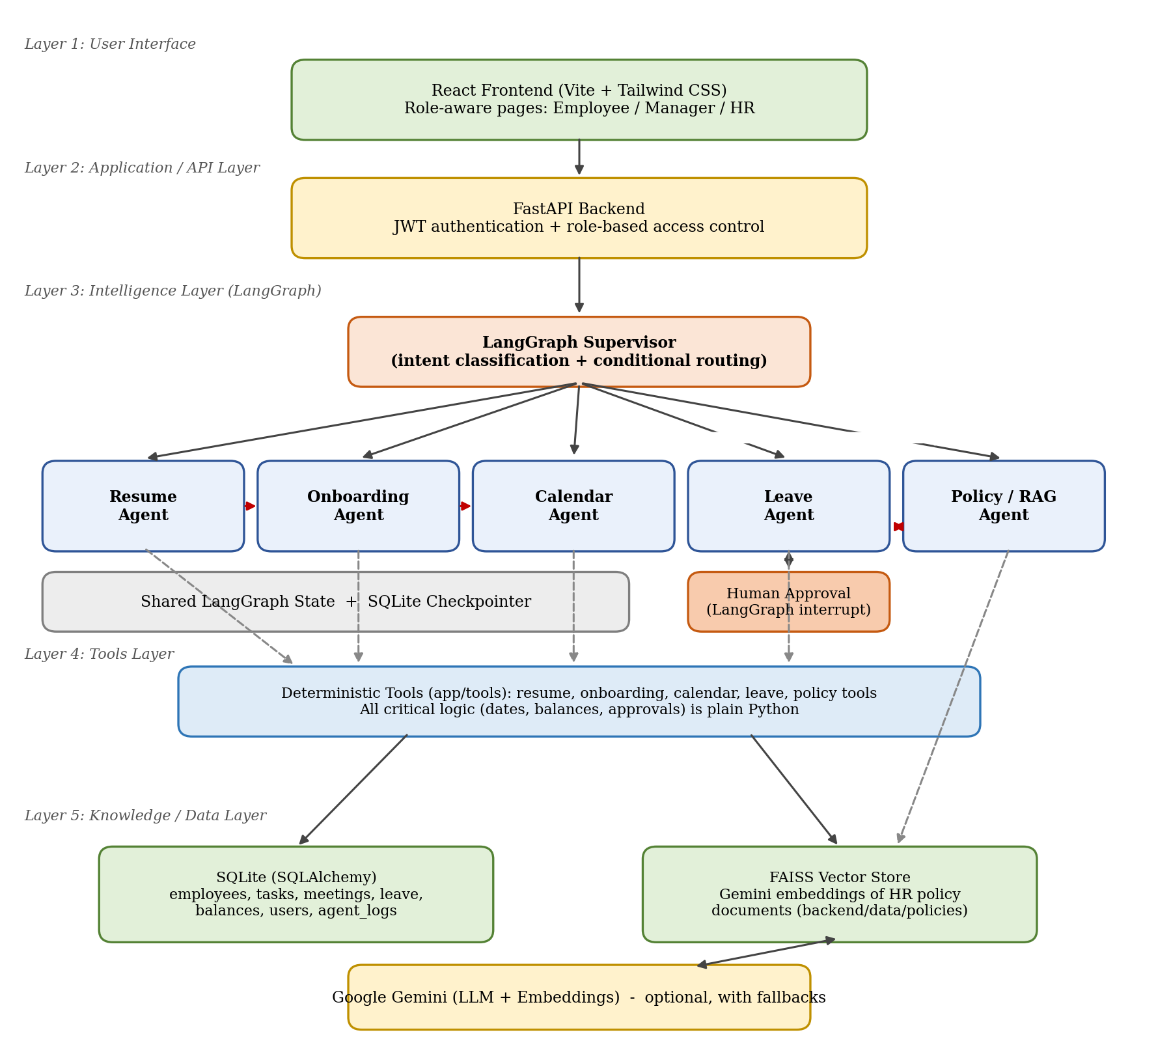
Figure 1: Layered agent architecture of the Agentic AI Employee Onboarding System

7.2 Agents
Agent | Responsibility | LLM Usage
Supervisor (supervisor.py) | Classifies requests and routes via conditional edges | Intent classification only (keyword fallback)
Resume Agent (resume_agent.py) | PDF to text to structured profile to employee record | Extraction only (regex/heuristic fallback); never makes hiring decisions
Onboarding Agent (onboarding_agent.py) | Generates role/department-aware task plan and stores tasks | None – deterministic templates
Calendar Agent (calendar_agent.py) | Schedules, reschedules and cancels meetings on a mock calendar with realistic availability | None – deterministic slot finding; provider is swappable
Leave Agent (leave_agent.py) | Parses leave requests, consults Policy Agent, applies balance/approval rules, pauses for human approval | Parses natural language only; dates, balances and approvals are deterministic code
Policy / RAG Agent (policy_agent.py) | FAISS retrieval over HR policy documents and grounded answers | Answers from retrieved chunks only; refuses when information is insufficient

7.3 Tools
Agents act through tools rather than merely claiming actions. The tools associated with the agents include:
- Resume PDF text extraction and profile builder
- Employee and login creation (with e-mail-prefix role mapping)
- Onboarding task generator (template based)
- Calendar tools for slot finding, scheduling, rescheduling and cancelling (provider isolated behind calendar tools)
- Leave tools (leave_tools.py) for date handling, balance checks, approval rules and status transitions
- FAISS retriever and keyword fallback retriever for policy retrieval
- SQLAlchemy CRUD functions with role-scoped queries
- Gemini API (LLM and embeddings) through LangChain
- Agent logger that writes to the agent_logs table

7.4 Memory
The system maintains state at several levels:
- Shared LangGraph state (app/graph/state.py) – the only channel through which agents communicate within a workflow
- SQLite-backed checkpointer – persists graph state so a leave workflow paused at the approval interrupt can resume later, even across server restarts
- Database records – employees, tasks, meetings, leave requests, balances and users
- Agent activity logs – a persistent record of agent steps
- FAISS index – long-term policy knowledge for retrieval
This allows workflows to be resumed and decisions to be traced.

7.5 Design Rules
The architecture follows these design rules:
- Agents act through tools, never by claiming actions.
- Critical business logic (balances, dates, statuses, approvals) is deterministic Python.
- Policies are retrieved through RAG, not pasted into prompts.
- Agents communicate only through shared LangGraph state.
- Each agent is small and specialised.
- Every important action writes an agent_logs row, shown live in the interface.
- Everything degrades gracefully without the LLM.
- Authorisation is enforced server-side on every request and every query, never by hiding interface links.

8. AGENT WORKFLOW AND ORCHESTRATION

8.1 Workflow Design
Every request enters through the FastAPI layer and is passed to the LangGraph Supervisor, which selects one of three workflows: resume upload, leave request or policy question. Requests for meetings and plans are also routed by the Supervisor to the Calendar and Onboarding agents respectively.

8.2 Resume Upload Workflow
Triggered by POST /api/resumes/upload (HR only).
supervisor -> resume_agent -> onboarding_agent -> calendar_agent -> END
(profile) (10 tasks) (6 meetings)

Step 1 — Input Collection. HR uploads a PDF resume.
Step 2 — Routing. The Supervisor identifies the resume workflow.
Step 3 — Profile Processing. The Resume Agent extracts text from the PDF and converts it into a structured profile (LLM extraction with heuristic fallback).
Step 4 — Employee Creation. The employee record is created and the state is passed to the next agent.
Step 5 — Plan Generation. The Onboarding Agent generates about ten role- and department-aware tasks and stores them.
Step 6 — Meeting Scheduling. The Calendar Agent schedules about six meetings in free slots.
Step 7 — Logging. Each step writes to the agent log.
Step 8 — User Presentation. The new employee’s detail page shows profile, tasks and meetings.

8.3 Leave Request Workflow
Triggered by POST /api/leave (or /api/me/leave for self-service).
supervisor -> leave_agent(intake) -> policy_agent -> leave_agent(decide)
|
auto-approved / rejected ----------------------+-> END
approval required ------> human_approval (interrupt)
| UI: Approve / Reject
v
finalize_leave -> END

Step 1 — Intake. The Leave Agent parses the request (natural language parsing by the LLM; dates and durations by code).
Step 2 — Policy Consultation. The Policy Agent retrieves relevant policy context and returns it through shared state.
Step 3 — Validation. Balances, dates and policy conditions are checked by deterministic code.
Step 4 — Decision. The request is auto-approved (for example, a one-day sick leave within the policy limit and balance), rejected, or marked as requiring approval.
Step 5 — Human Approval. For approval-required requests the graph stops at a LangGraph interrupt(). The request appears under Awaiting Approval.
Step 6 — Resume. When the manager or HR approves or rejects, the graph resumes with Command(resume=...), the database and balance are updated and decided_by records who decided.
Step 7 — Finalisation. The request status is finalised and logged.

8.4 Policy Question Workflow
supervisor -> policy_agent -> END

The question is routed to the Policy Agent, which retrieves relevant policy chunks and returns a grounded answer along with the source files.

8.5 State, Persistence and Fallback
- All agents read and write a shared graph state defined in app/graph/state.py.
- A SQLite checkpointer persists the state so that paused workflows survive restarts.
- If the checkpoint thread is unavailable, the API falls back to a deterministic database decision so approvals never get stuck.
- If the Gemini key is absent, extraction uses heuristics, policy answers use keyword search over the documents, and intent routing uses keywords.

9. AGENTIC RAG IMPLEMENTATION
The system implements Retrieval-Augmented Generation for HR policy questions. The Policy Agent is also called by the Leave Agent, so retrieval is used inside another workflow, which makes the RAG agentic rather than a standalone question-answering feature.

9.1 Retrieval Architecture
HR Policy Documents (backend/data/policies/*.txt)
|
Preprocessing / chunking (rag/ingest.py)
|
Gemini Embeddings
|
FAISS Vector Store
|
Retriever (semantic; keyword fallback in rag/retriever.py)
|
Relevant Policy Chunks
|
Gemini LLM (answers from retrieved chunks only)
|
Grounded Response + Source Files

The FAISS index is built during application start-up (lifespan warm-up). When embeddings are unavailable, the retriever falls back to keyword search over the same documents.

9.2 Knowledge Retrieval
When a user asks a question such as “How many casual leave days can I take?”, the retrieval system identifies the relevant:
- leave-type rules and limits,
- approval conditions,
- policy documents and sections containing the answer.
The retrieved chunks are supplied to the language model. The answer is returned together with the list of source files. When the Leave Agent handles a leave request, it requests policy context from the Policy Agent in the same way and uses it during its decision step.

9.3 Generation Process
The LLM receives:
User Question + Retrieved Policy Chunks (+ request context when called by the Leave Agent)

and produces a response based only on that context. If the retrieved context is insufficient, the agent returns “I could not find enough information…” rather than guessing. This reduces dependence on the model’s general knowledge for organisation-specific policy details.

9.4 Retrieval Quality Evaluation
Possible evaluation measures include:
- Retrieval relevance
- Context precision
- Context recall
- Answer groundedness
- Response relevance
- Correct refusal rate for questions not covered by the policies
These measures are computed on a test set of policy questions prepared from the five policy documents; the measured values are reported in Section 11.

10. SYSTEM IMPLEMENTATION

10.1 Frontend
The frontend is a React single-page application built with Vite and styled with Tailwind CSS. It provides interfaces for:
- Login and demo accounts
- Self-service pages: My Home, My Tasks, My Leave, My Meetings and My Team
- HR/Manager pages: Dashboard, Employees, Resumes, Onboarding, Calendar and Leave
- Policies (policy chat with sources)
- Agent Activity (live agent log feed) and Settings
Supporting modules include a dark sidebar layout with role-aware navigation (Layout.jsx), token state and 401 handling (AuthContext.jsx), route guards (RequireAuth and RequireRole), reusable UI components, an Axios client that attaches the bearer token, and a useFetch hook.

10.2 Backend
The backend is implemented in Python with FastAPI. It is responsible for:
- Receiving and validating user requests (Pydantic schemas)
- Authenticating users and enforcing roles
- Invoking LangGraph workflows
- Performing deterministic calculations through tools
- Communicating with the database
- Calling Gemini through LangChain where enabled
- Returning responses to the frontend
At start-up (lifespan) the application initialises the database, seeds demo data and warms the FAISS index. Key API groups are summarised below.
Area | Representative Endpoints
Authentication | POST /api/auth/login, GET /api/auth/me, POST /api/auth/demo-accounts
Employees (HR) | POST/GET /api/employees, GET /api/employees/role-preview, PATCH /api/employees/{id}/role
Self-service | GET /api/me/summary, /api/me/tasks, /api/me/meetings, /api/me/leave, /api/me/leave/balances, /api/me/profile
Team (Manager/HR) | GET /api/team, GET /api/team/{employee_id}
Resumes (HR) | POST /api/resumes/upload
Tasks and meetings | GET/PATCH /api/tasks, GET/POST/PATCH /api/meetings
Leave | GET/POST /api/leave, POST /api/leave/{id}/approve, POST /api/leave/{id}/reject, GET /api/leave/balances
Policy and agents | POST /api/policy/query, POST /api/agent/run, GET /api/agent/logs, GET /api/agent/status
Dashboard | GET /api/dashboard/stats

10.3 Database and Security
The database layer uses SQLAlchemy models with SQLite, seeded through db/seed.py, and CRUD functions in db/crud.py that filter every query by the caller’s scope.
Authentication
Passwords are hashed with PBKDF2-SHA256 and tokens are HS256 JWTs carrying the subject, role and employee_id. Every endpoint except /api/health, /api/auth/login and /docs requires a bearer token.
Roles
Role | Access
EMPLOYEE | Only their own tasks, meetings, leave and balances; cannot see other employees, the directory, resumes or approve anything
MANAGER | Everything an employee can, plus direct reports, a team-scoped dashboard and approval of their reports’ leave; no access to resumes or the full directory
HR | Full access: all employees, resume upload, organisation-wide dashboard and company-wide leave decisions

Role Assignment by E-mail Prefix
When HR creates an employee, the access role is derived from the text before the employee id in the e-mail address (for example hr1000@… gives HR, manage1234@… gives MANAGER and employee1021@… gives EMPLOYEE). Prefixes are case-insensitive and separators are ignored. An unrecognised prefix is rejected with HTTP 422 instead of silently creating an under-privileged account. HR can override the role with login_role and set a custom login_password, and a role-preview endpoint shows the role an address would receive.
Scope Enforcement
Scope is enforced on reads as well as writes. An employee requesting another employee’s tasks receives an empty list, and self-service endpoints derive the employee from the token and ignore any employee_id in the request body. Roles are read from the database on each request, so a role change takes effect on the user’s next login.

10.4 AI Integration
Google Gemini is integrated through LangChain for:
- Intent classification in the Supervisor
- Structured extraction from resume text
- Natural-language leave request parsing
- Grounded policy answers from retrieved chunks
- Embeddings for FAISS semantic retrieval
The LLM is deliberately limited to language tasks. Onboarding plans, meeting scheduling, leave balances, dates and approval logic are deterministic. The system works without a key (for example with heuristic extraction and keyword-based policy search), and the key is supplied through backend/.env using GEMINI_API_KEY.

10.5 Prototype Screenshots
The following screenshots illustrate the main interfaces of the prototype.
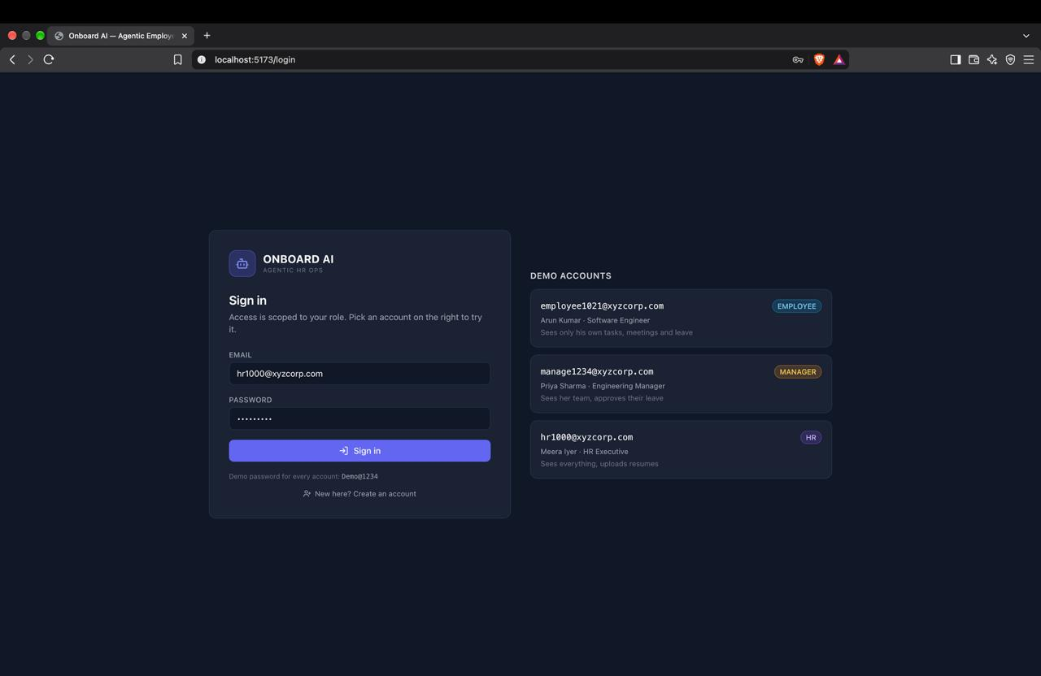

Figure 2: Login page with demo accounts
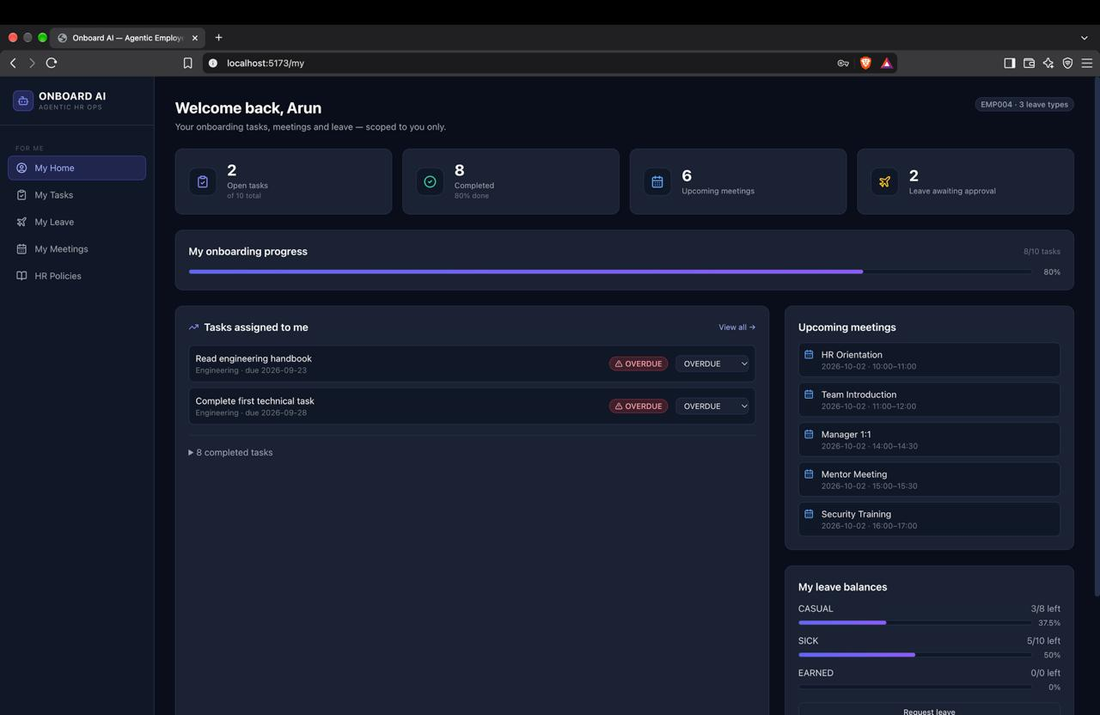

Figure 3: My Home – employee self-service landing page
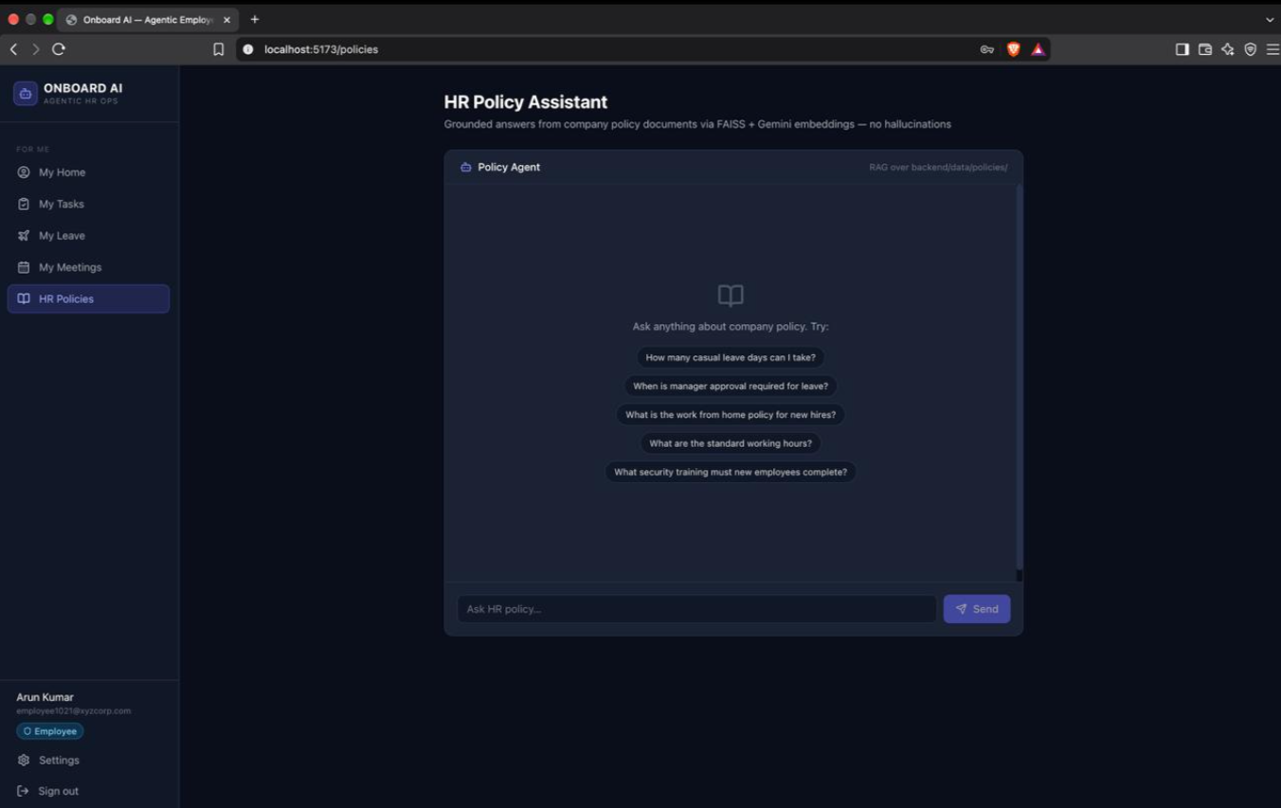

Figure 4: HR Dashboard with organisation-wide statistics
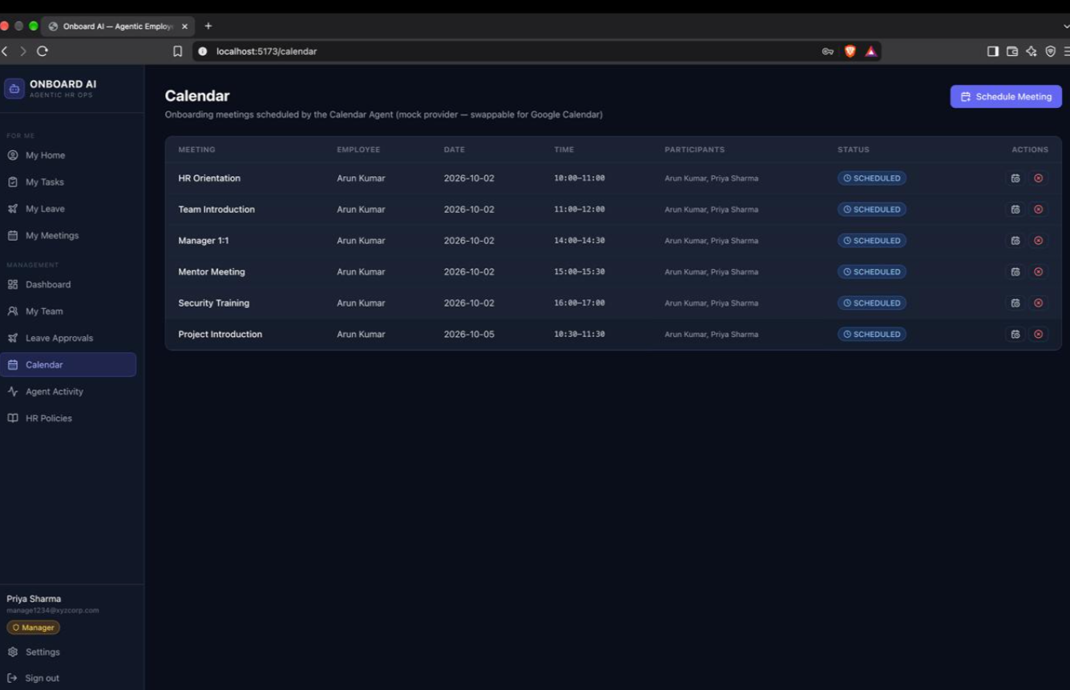

Figure 5: Resume upload and generated onboarding plan
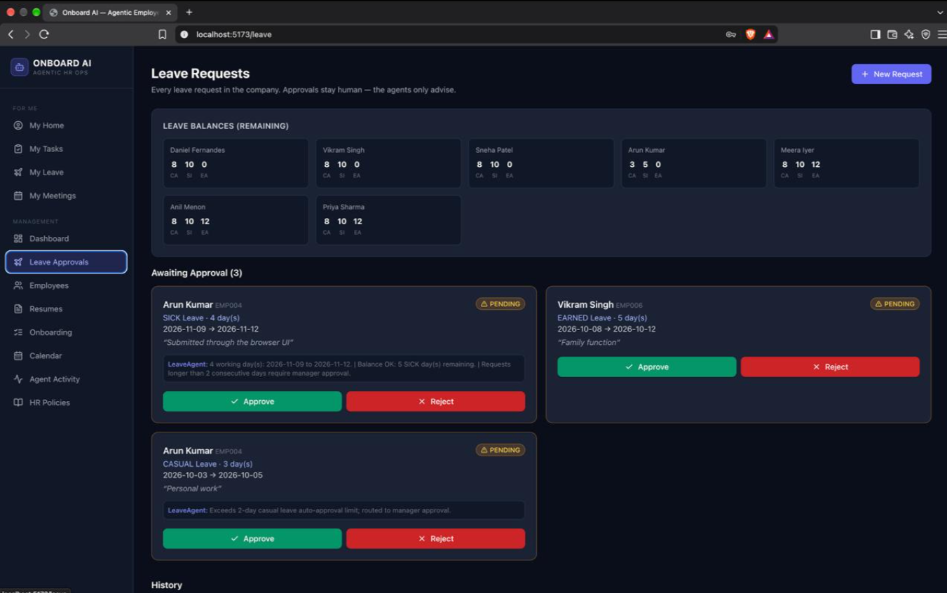

Figure 6: Leave request awaiting human approval
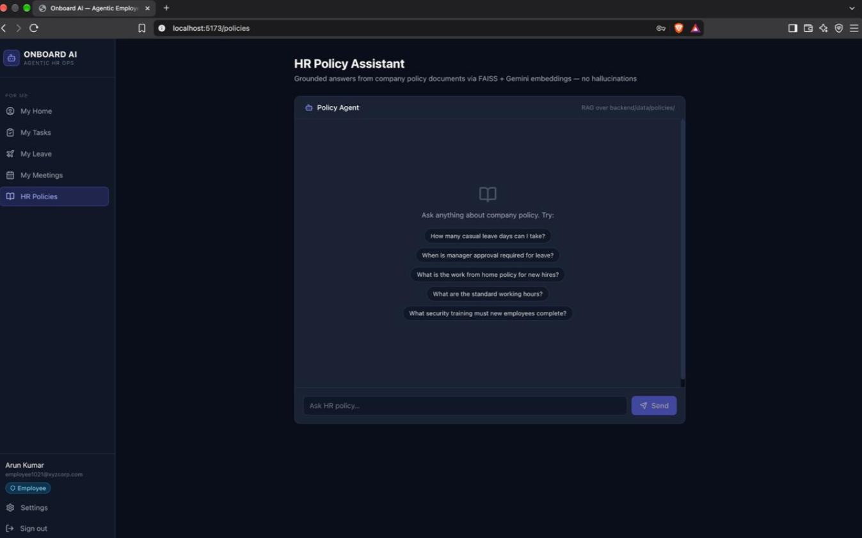

Figure 7: Policy chat with grounded answer and sources
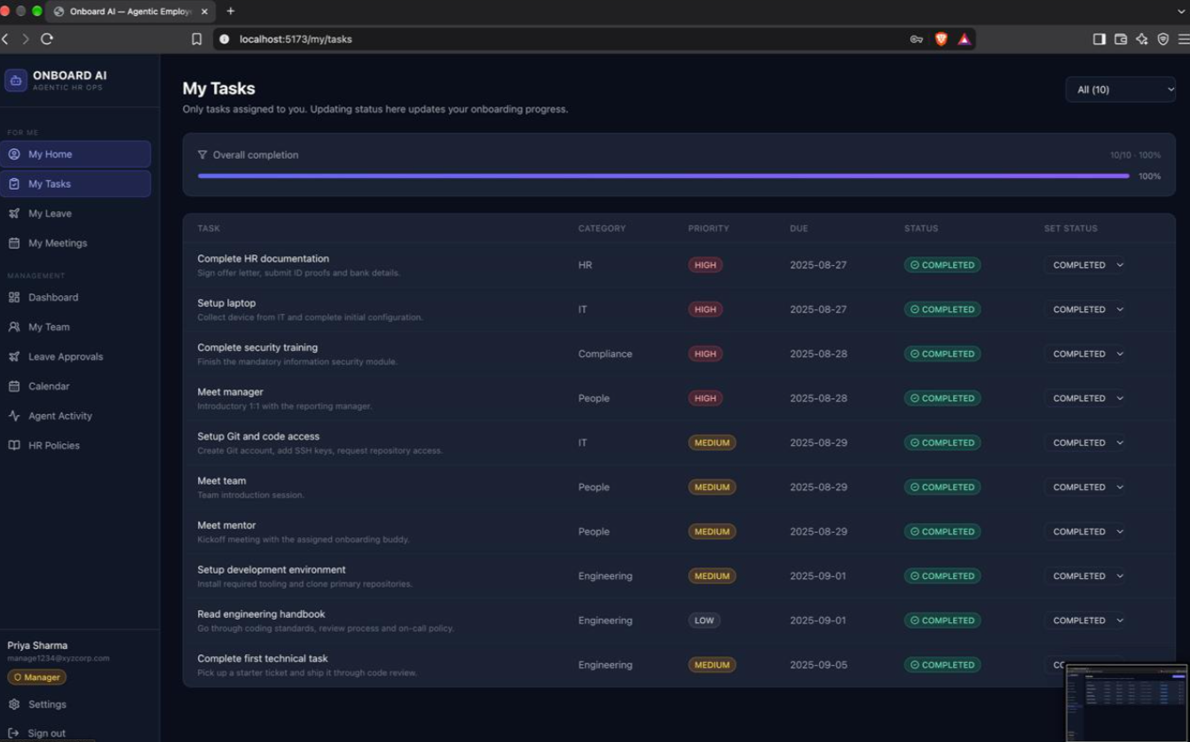

Figure 8: Agent Activity feed showing real agent logs

11. EXPERIMENTAL EVALUATION AND RESULTS

11.1 Evaluation Strategy
The system is evaluated on whether its workflows complete correctly, its decisions follow the deterministic rules, its access control holds, and its AI components stay grounded. Important evaluation dimensions include:
- Workflow completion
- Decision correctness
- Access-control and security
- Policy-answer relevance and groundedness
- Response time
- Robustness and graceful degradation

11.2 Workflow Completion
For each workflow run:
Workflow Completion Rate = (Successful Runs / Total Runs) x 100

For the resume workflow, a successful run must create the employee record, about ten onboarding tasks and about six meetings, and write log entries for each agent. The functional test cases used are listed below; the Result column is completed from testing.
ID | Scenario | Expected Behaviour | Result
T1 | HR uploads a PDF resume | Employee created, ~10 tasks generated, ~6 meetings scheduled, agent logs written | [Pass/Fail]
T2 | Employee files 1-day SICK leave with sufficient balance | Auto-approved; decided_by = AutoApproval | [Pass/Fail]
T3 | Employee files CASUAL leave of 3+ days | Workflow pauses; request appears under Awaiting Approval | [Pass/Fail]
T4 | Manager approves the pending request | Graph resumes, status and balance updated, decided_by = manager | [Pass/Fail]
T5 | Server restarted while a request awaits approval | Workflow resumes from the SQLite checkpoint | [Pass/Fail]
T6 | Run without GEMINI_API_KEY | System still works using heuristic and keyword fallbacks | [Pass/Fail]

11.3 Decision Accuracy
Leave decisions can be compared against the expected outcome computed independently from the policy rules:
Policy Rule + Balance
|
Expected Decision (approve / reject / needs approval)
|
System Decision -> Compare -> Match / Mismatch

Decision Accuracy = (Matching Decisions / Total Test Requests) x 100. Because balances, dates and status transitions are deterministic code, the expected result is full agreement; the LLM only influences parsing of the request text. The same comparison is applied to task generation (correct task set for the role) and meeting scheduling (no conflicts, within work hours and outside lunch).

11.4 Access-Control and Security Testing
Access control is verified with negative tests:
ID | Test | Expected Result | Result
A1 | Request without a token | 401 Unauthorised | [Pass/Fail]
A2 | Employee requests /api/tasks?employee_id=<other> | Empty list | [Pass/Fail]
A3 | Employee opens /employees in the browser | Redirected back; nav does not offer it | [Pass/Fail]
A4 | Manager requests a non-report | Empty result | [Pass/Fail]
A5 | Employee sends another employee_id in /api/me/leave body | Ignored; token identity used | [Pass/Fail]
A6 | HR creates a user with an unrecognised e-mail prefix | 422 with list of valid prefixes | [Pass/Fail]
A7 | Role changed via PATCH /api/employees/{id}/role | Applies on the user’s next login | [Pass/Fail]

11.5 AI Response Evaluation
The Policy Agent and the LLM-assisted extraction can be evaluated using:
- Relevance – does the answer address the question?
- Completeness – does it include the applicable limits and conditions?
- Groundedness – is every statement supported by retrieved text, with sources listed?
- Correct refusal – does it return “I could not find enough information…” when the policies do not cover the question?
- Extraction quality – accuracy of the profile fields extracted from resumes compared with the source resume
- Response consistency across repeated queries

11.6 Performance Evaluation
System-level measurements can include:
Metric | Purpose | Measured Value
API response time | Backend performance | [from testing]
Resume workflow time | End-to-end resume, onboarding and calendar pipeline | [from testing]
Leave workflow time | Decision latency until approval interrupt | [from testing]
Policy query time (with and without Gemini) | RAG and LLM latency | [from testing]
FAISS index build time | Start-up cost of ingestion | [from testing]
Error rate | Reliability | [from testing]

Actual numerical values are to be inserted from testing on the deployed prototype.

12. COMPARISON, INNOVATION AND SCALABILITY

12.1 Manual / Conventional Onboarding vs the Proposed System
Aspect | Conventional Onboarding | Agentic Onboarding System
Profile creation | Manual data entry | Resume PDF parsed into a structured profile
Task planning | Checklists prepared by hand | Role- and department-aware plan generated automatically
Meeting scheduling | E-mail coordination | Calendar Agent finds conflict-free slots
Leave decisions | Manual checking of balances and policy | Deterministic rules with auto-approval and human approval
Policy questions | Ask HR / search documents | RAG answers with sources
Access control | Varies by tool | Server-side role-based control on every query
Auditability | Scattered records | Agent Activity log of each step
AI dependence | None or unrestricted chatbot | LLM limited to language tasks; works without it
Extensibility | Limited | Swappable calendar provider and modular agents

This comparison describes system characteristics rather than assigning an overall ranking.

12.2 Innovation
The project combines several requirements that are often handled separately:
Multi-Agent Orchestration + Deterministic Business Logic + Human-in-the-Loop + RAG + Role-Based Security + Auditability
The central innovation is the disciplined use of AI: agents coordinate through a shared LangGraph state, critical decisions remain deterministic, sensitive decisions can pause for a human using a real interrupt and checkpointer, policy answers are grounded in retrieved documents, and the entire system degrades gracefully without the LLM.

12.3 Scalability
The system can be extended from a prototype to a broader HR platform.
Database Scalability
The SQLAlchemy layer allows migration from SQLite to PostgreSQL with Alembic migrations.
AI Scalability
New agents can be added as small LangGraph nodes, and the LLM can be swapped since it is confined to language tasks.
Knowledge Scalability
Additional policy documents can be added to the policies folder and re-ingested into the FAISS index.
Application Scalability
The backend and frontend are containerised and can be extended with:
- Google Calendar or Microsoft Graph behind the calendar tools
- E-mail and Slack notifications for approvals
- LangSmith tracing for observability
- OCR for scanned resumes
- Token revocation and a managed secret store

12.4 Real-World Applicability
Potential applications include:
- Corporate HR onboarding
- Startups and SMEs
- IT services and consulting firms
- Educational institutions and training organisations
- HR-tech products and outsourced HR services
A future version could connect with real calendars, HRMS platforms and messaging tools, allowing the flow to move from resume received to employee fully onboarded with minimal manual effort.

13. CONCLUSION AND FUTURE WORK

13.1 Conclusion
The Agentic AI Employee Onboarding System demonstrates how multiple specialised agents can automate a real business process while remaining controllable. LangGraph orchestrates a Supervisor and five agents – Resume, Onboarding, Calendar, Leave and Policy (RAG) – through a shared state, with a SQLite checkpointer that allows workflows to pause for human approval and resume later.
Unlike a standalone chatbot, the system uses the LLM only for language tasks such as extraction, intent classification, request parsing and grounded answers. Plans, scheduling, leave balances, dates and approvals are implemented as deterministic Python tools. Policy answers are grounded in retrieved documents through FAISS and Gemini embeddings, and the system falls back gracefully when the LLM is unavailable.
The full-stack implementation – FastAPI, SQLAlchemy/SQLite, React with Tailwind CSS, JWT-based authentication with Employee, Manager and HR roles, and Docker deployment – shows that agentic AI can be integrated into a practical application where the objective is not merely to generate text but to support secure, auditable, multi-step decision-making.

13.2 Future Work
- Real calendar integration – add a Google Calendar or Microsoft Graph provider behind the calendar tools, whose interface is already isolated.
- Notifications – send e-mail or Slack notifications to managers when a leave approval interrupt fires.
- Observability – add LangSmith tracing for graph observability.
- Scanned resume support – add OCR (for example Gemini vision) for scanned resumes.
- Production database – move to PostgreSQL with Alembic migrations beyond the prototype stage.
- Pro-rated leave – support pro-rated leave balances for mid-year joiners.
- Stronger security – add refresh tokens and token revocation, and move the JWT secret to a real secret manager.

